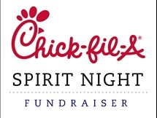

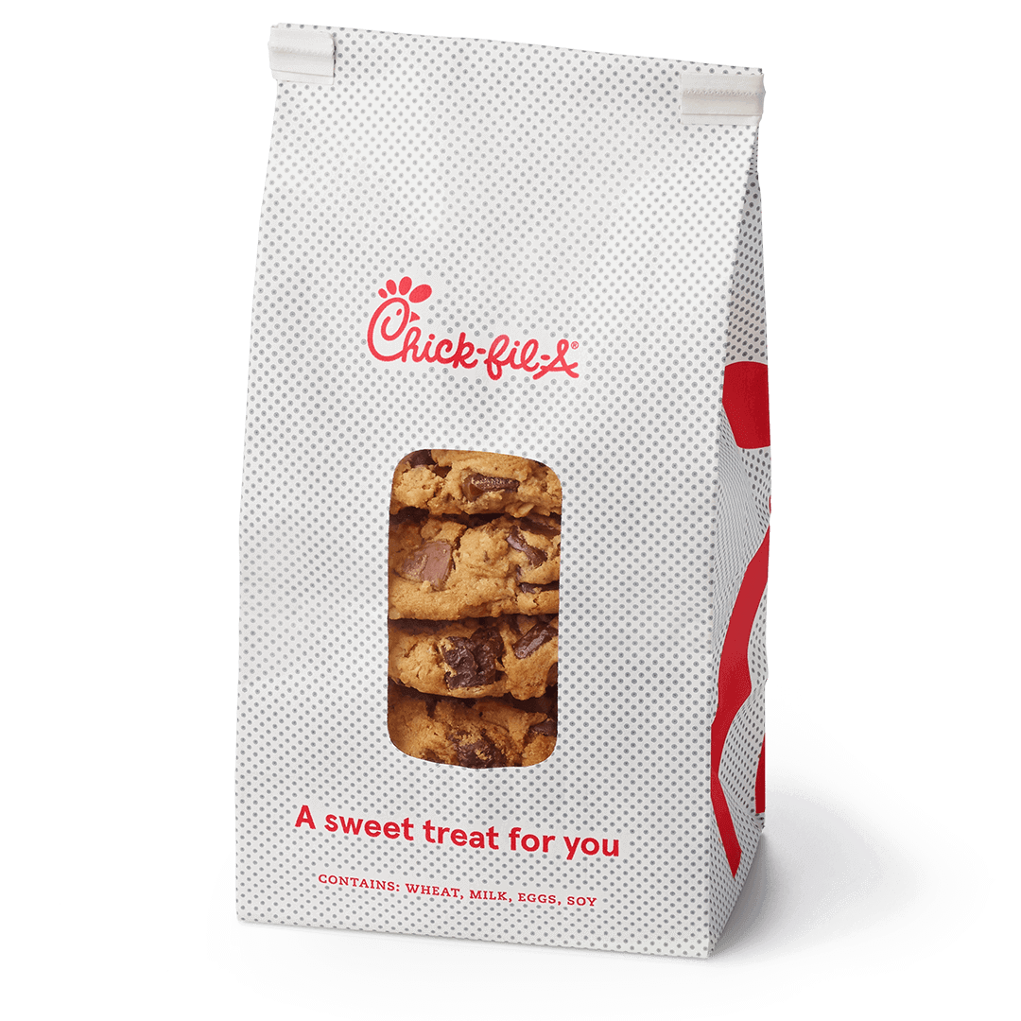 Pre-Selling Form

$20.00 per Box

Each Box will contain 18 cookies

Money due date is Oct 15, 2021

Cookies are available for pick up Nov 4, 2021, at Columbus Chick –fil-A

Please join us for dinner between 5pm-7pm.

15% of all Sales will go to United Way.

Please Help Support our Agencies.

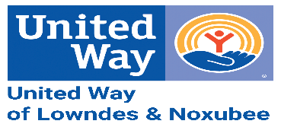

**Organization:**

**Contact Name:**

**Contact Phone:**

**Make Checks Payable to: United Way of Lowndes & Noxubee ( UWLN)**

|  |  |  |  |  |
| --- | --- | --- | --- | --- |
| Customers Name | Phone Number | No. of Cookies | Amount | Total |
|  |  |  |  |  |
|  |  |  |  |  |
|  |  |  |  |  |
|  |  |  |  |  |
|  |  |  |  |  |
|  |  |  |  |  |
|  |  |  |  |  |
|  |  |  |  |  |
|  |  |  |  |  |
|  |  |  |  |  |
|  |  |  |  |  |
|  |  |  |  |  |
|  |  |  |  |  |
|  |  |  |  |  |
|  |  |  |  |  |
|  |  |  |  |  |
|  |  |  |  |  |
|  |  |  |  |  |
|  |  |  |  |  |
|  |  |  |  |  |
|  |  |  |  |  |
|  |  |  |  |  |
|  |  |  |  |  |
|  |  |  |  |  |
|  |  |  |  |  |

